**Daily Scrum or Standup Meeting**

Team name: Group 8_________________________

Scrum Master: Cole_______________________

Date: 4-14_______________________________

|  |  |  |  |
| --- | --- | --- | --- |
| **Team Member** | **What did you do since the last scrum?** | **What do you plan to do before the next scrum?** | **What obstacles do you have?** |
| Cole | Worked on finished paperwork for milestone 3 | Try and squish those last bugs | Time, a small child |
| Austin | Finished final polish of customer interface | Catch my breath | Time |
| Jeremy | N/A | N/A | N/A |
| Logan | N/A | N/A | N/A |
|  |  |  |  |

# Burndown

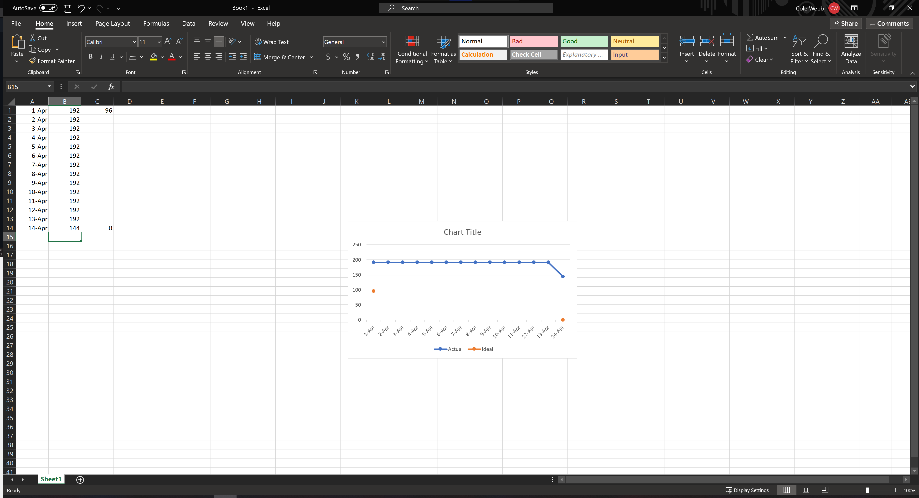

# Screenshot of you project board

